Github Windows – Tutorial

Step – 1:
Download Github for Win7 @ Git for Win7

Step – 2:
Install it. It takes time.After installing you will see two icons on the desktop opens the github gui view and the other is for bash prompt.

Step – 3:
Give your credentials which you can create either on the current window or on the github site (link)

Step – 4:
Now set the workspace path. You must sink the code to make it available on the web such the you can retrieve (check out) it later when needed.

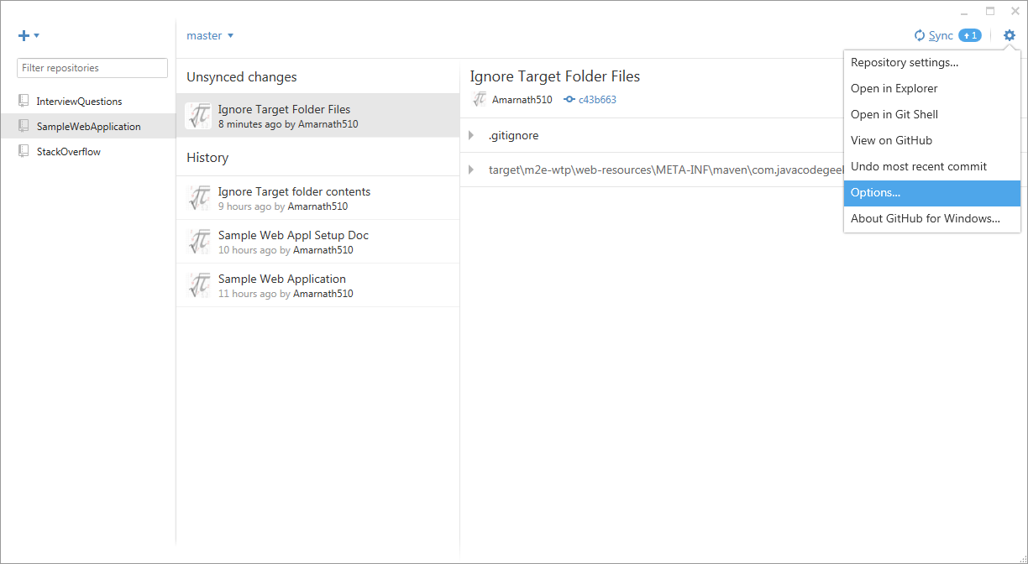
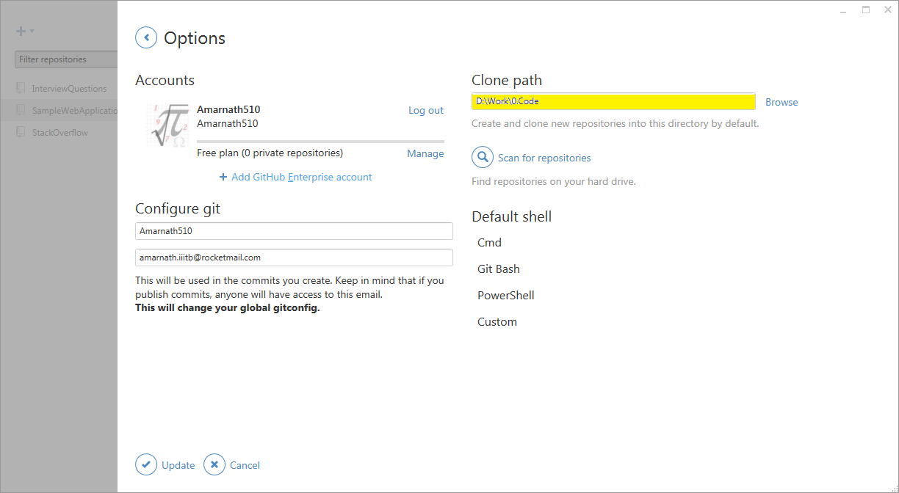
In the above figure, you can see the Clone path is given to point a directory. I have created a workspace named 0.code using eclipse in the D-drive. You may have many project(s) created in it.
So now we have to sink a project with github such that we can save the code in the github repository.

Step – 5:
So now we have to create a repository to save a project. Here I am creating a repository for each type of project. On the top left of the below image you can see a plus sign on which if you click you can see a window which asks to give the repository name. I have already created a Spring project (SampleWebApplication) in eclipse.

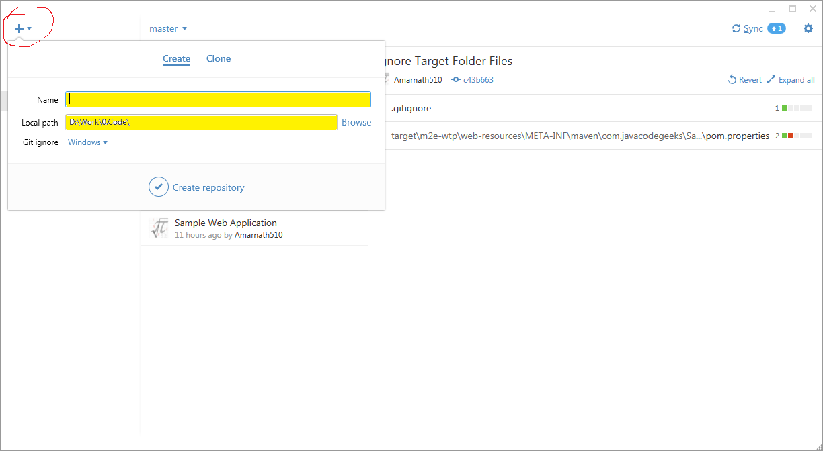
So you need to set the local path to the workspace directory and then give name as the same name of the project which is present inside the workspace. In this case SampleWebApplication is given as name which is same as the project which is present inside the workspace.

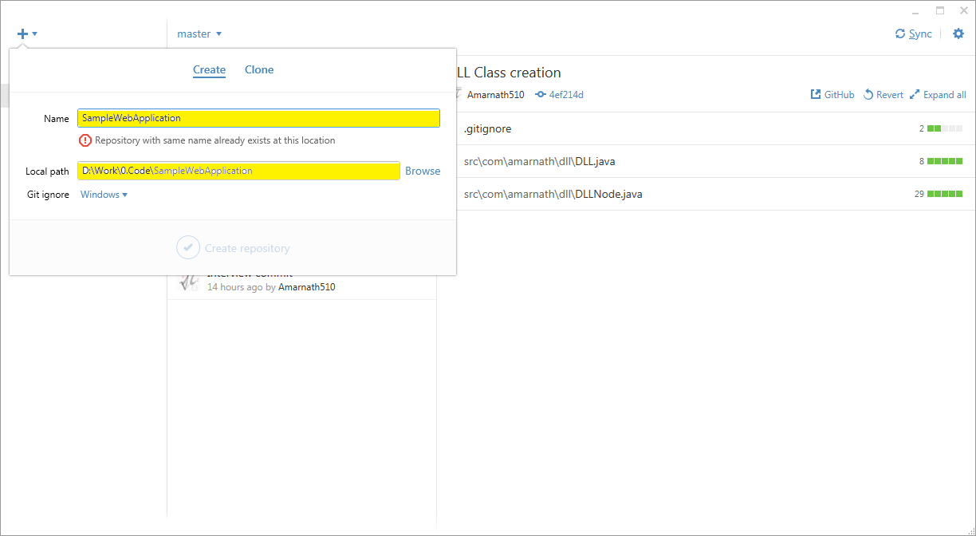
Now you can see all the files present in the project folder on your Github UI.
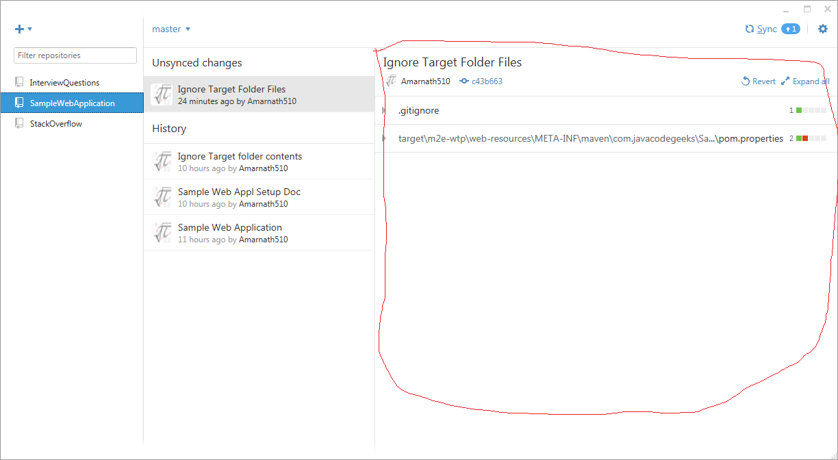
Step – 6:
So now I have updated index.jsp file. Now you can see the file in the github UI which says that this file needs to be commit. So in the uncommited changes drop down give the Summary and Description and click on commit.

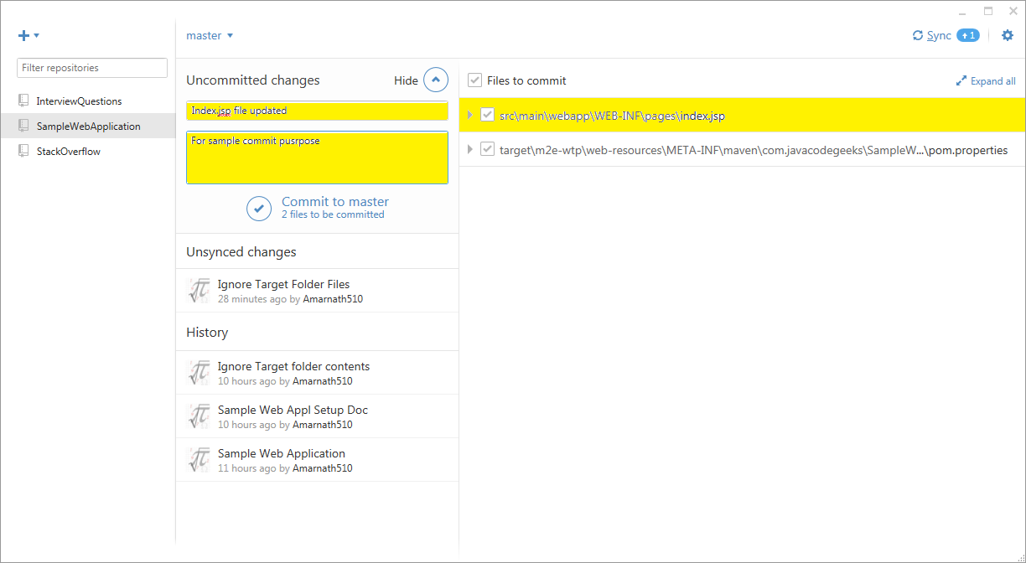
Step – 7:
Now after doing this I had a doubt. So how will I checkout if tomorrow I have lost the code on my disc.
I am not seeing any option here on the Github UI which shows me to checkout code.
But wait goto Github on Web where you should see the project there.
NOPE wait how do your account know that you have a project and you have checked in. For this you need to sync the code changes in to your account.
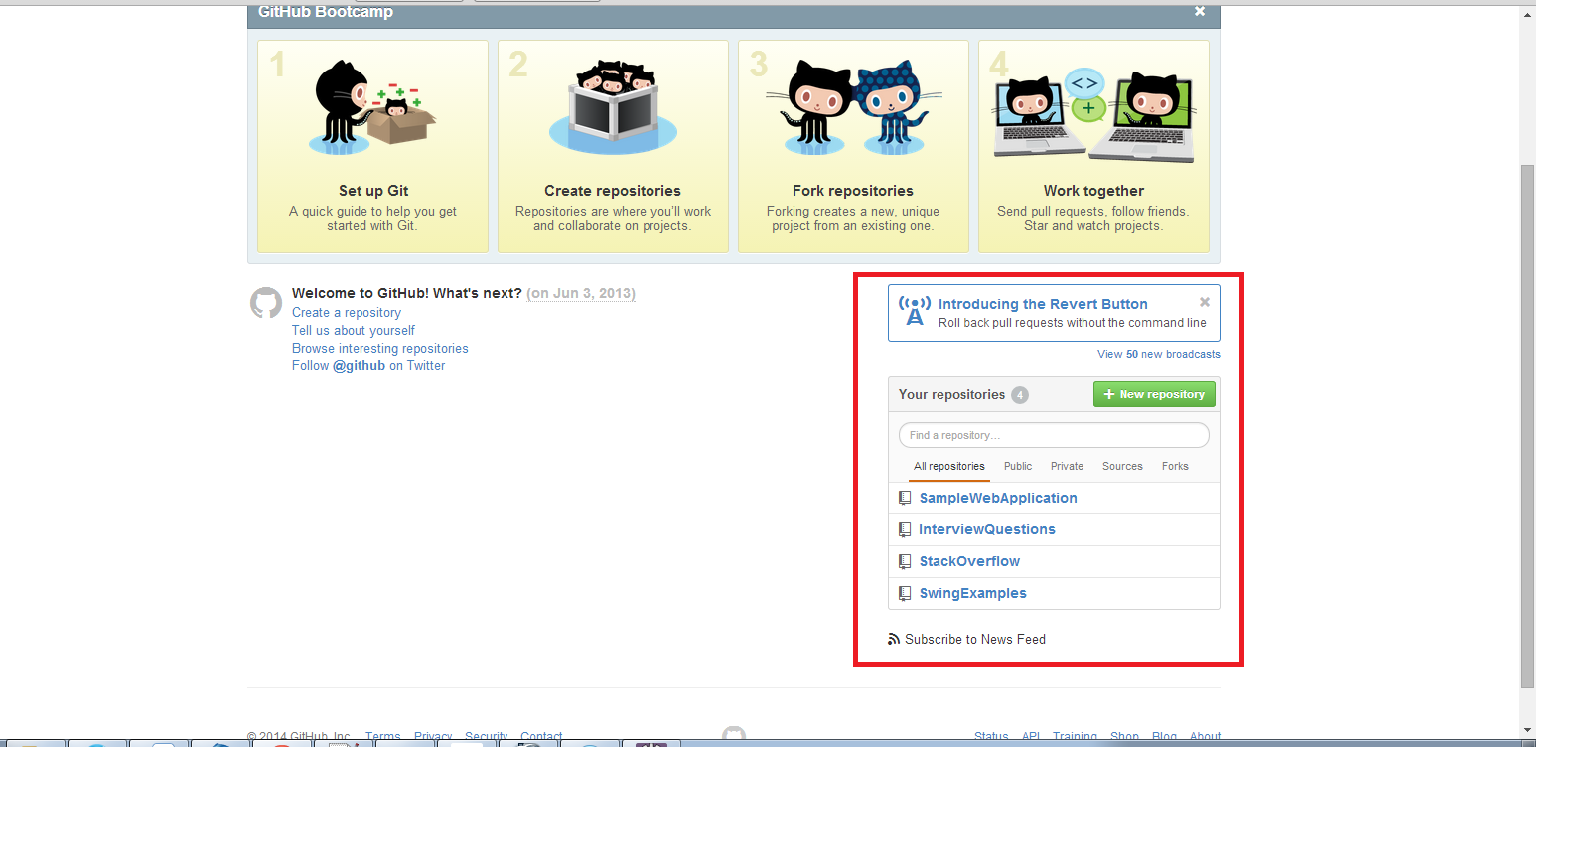

Step – 8:
How do we sync our project code? See the Sync in the below figure. After every commit you just need to sync the code with your repository and only after that you will be able to see the code on your account on the web.
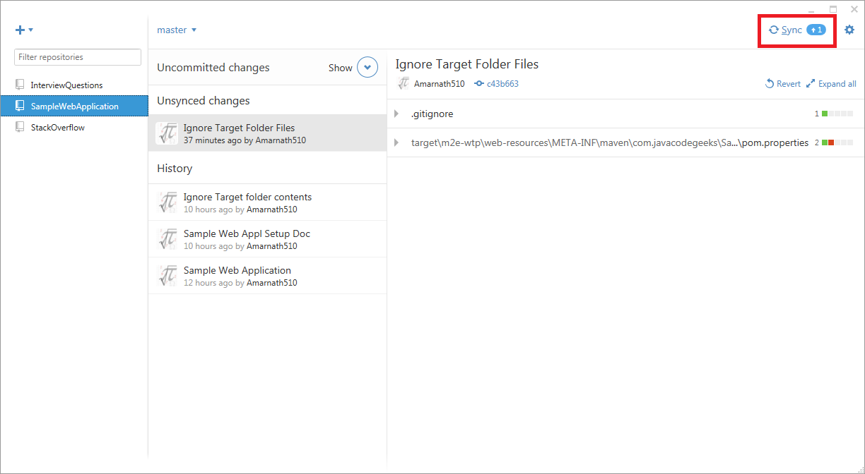
Step – 9:
We no need to check in the target folder, .class, .settings, .classpath etc.
So inorder to achieve this we need to mention this in our .gitignore file.

So in the .gitignore file go to end and then type the following,

.classpath
.project
.settings/
target/

